

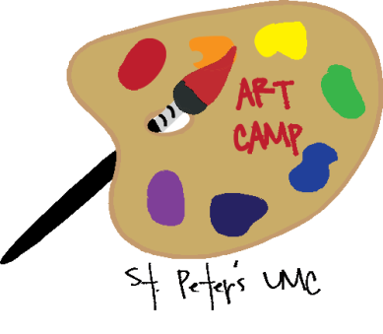

**Elementary Art Camp**

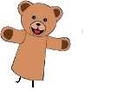

**COMBO Camp**

**Pre-registration and**

**Pre-payment is required for all camps**.

Please contact the church office at (804) 883-5596 or stpetersumc@gmail.com for a registration form or visit our website at stpetersumc.org

**Middle**

**Art**

**Camp**

# **Calendar of Events**

June 24 - 28 9 – 12 Middle Art Camp

Gallery Show 6/30 at 10am

July 29 – Aug 2 9 – 12 Combo Camp

Exhibition 8/4 at 10am

August 19-23 9 – 12 Elementary Art Camp

Gallery Show 8/25 at 10am

August 25 10 am End of Summer Celebration

**2019 Summer Fun for kids in**

**grades 1-9**

***Inspired by God***

***Designed for Fun***

***Created for All***

**St. Peter’s**

**Summer**

**Kids Camps**

**$30/week**

**St. Peter’s United Methodist Church**

**15599 Mountain Road**

**Montpelier, Va. 23192**

**(804) 883-5596**

**SAVE**

**THE**

**DATES**



**Elementary Art Camp**

**Middle**

**Art Camp**

**All camps feature a daily bible lesson, snack, and tons of hands on exploration and fun!**

**Middle Art Camp** will be held June 24th – 28th from 9 am – 12 pm and is open to all rising 6th – 9th graders. This camp is a wonderful opportunity to explore new ideas and techniques in an atmosphere that is only limited by one’s imagination. A variety of techniques and mediums will be introduced. There will be a gallery showing of all completed art work at 10 am on Sunday, June 30th. There is a registration fee of $30.00 per person to cover the cost of materials. The camp is limited to 15 participants.

**Elementary Art Camp**

**August 19th - 23rd**

**Rising 1st - 5th graders**

**Middle Art Camp**

**June 24th - 28th**

**Rising 6th - 9th graders**



**COMBO Camp**

**COMBO Camp**

**July 29th - August 2nd**

**Rising 3rd - 7th graders**

**COMBO Camp** will be held July 29th – August 2nd from 9 am – 12 pm and is open to all rising 3rd – 7th graders. This is a new camp this summer and will be a wonderful opportunity for campers to explore a variety of themes in one week. This summers themes include cooking, puppet making, science and crafting. There will be an exhibition of the students completed projects at 10 am on Sunday, August 4th. There is a registration fee of $30.00 per person to cover the cost of materials. The camp is limited to 15 participants.

**Elementary Art Camp** will be held August 19th – 23rd from 9 am – 12 pm and is open to all rising 1st – 5th graders. This camp is the perfect opportunity for young artists to be introduced to new materials, mediums and techniques. Campers will be making a diverse range of pieces that will allow them to explore their inner creativity. There will be a gallery showing of all completed art work at 10 am on Sunday, August 25. There is a registration fee of $30.00 per person to cover the cost of materials. The camp is limited to 15 participants.